REPORT OF THE TRANSNATIONAL WORKSHOP ON ENTREPRENEURIAL EDUCATION
UNIVERSITY OF PISA
DEPARTMENT OF ECONOMICS AND MANAGEMENT
25TH-27TH MARCH 2026

Marco E.L. Guidi
Università di Pisa
Dipartimento di Economia e Management
Pisa, Italy
marco.guidi@unipi.it

Andrea Dello Sbarba
Università di Pisa
Dipartimento di Economia e Management
Pisa, Italy
andrea.dellosbarba@unipi.it

Monica Lupetti
Università di Pisa
Dipartimento di Filologia, Letteratura e Linguistica
Pisa, Italy
monica.lupetti@unipi.it

Abstract
The Transnational Workshop on Entrepreneurial Education, organized within Work Package 2 of the AFJ Project (Addressing Future Jobs through Entrepreneurial Skills Development and Work-Integrated Learning), was held at the University of Pisa from 25 to 27 March 2026 as an international capacity-building initiative aimed at strengthening entrepreneurship education within South African Higher Education Institutions. The workshop brought together lecturers, entrepreneurship educators, career-service staff and institutional representatives from the four South African partner institutions together with European experts from the University of Pisa, Consorzio QUINN of the University of Pisa and the University of Peloponnese.

The training activities focused on the presentation, discussion and co-design of 20 innovative teaching tools and related pedagogical guidelines aimed at promoting experiential learning, entrepreneurial mindsets and work-integrated learning approaches across different disciplinary fields, including business management, accounting, marketing and agriculture. Through interactive methodologies combining lectures, case studies, role-playing activities, collaborative reflection and practical sector-based clinics, participants actively engaged in the adaptation of the proposed tools to the South African educational context.

The workshop achieved a high level of participation and generated extensive discussion on curriculum innovation, entrepreneurial ecosystems, employability and university-business cooperation. The pre- and post-test analysis demonstrated a significant increase in participants’ knowledge and pedagogical competences, while satisfaction questionnaires confirmed the strong relevance, effectiveness and applicability of the training contents.

Overall, the workshop successfully contributed to the achievement of WP2 objectives by reinforcing institutional capacities in entrepreneurship education, fostering international cooperation and preparing the South African participants to act as multipliers through the implementation of national dissemination workshops within their own institutions.

- Introduction

The Transnational Workshop on Entrepreneurial Education was organized within the framework of Work Package 2 (WP2) of the AFJ Project – Addressing Future Jobs through Entrepreneurial Skills Development and Work-Integrated Learning – and took place at the Department of Economics and Management of the University of Pisa from 25 to 27 March 2026.

WP2 is functional to the achievement of Specific Objective 1 of the AFJ project and focuses on strengthening the capacity of Higher Education lecturers and educators in entrepreneurship education through experiential learning methodologies, work-integrated learning approaches and innovative teaching tools.

The workshop was conceived as an international capacity-building activity aimed at presenting and testing a set of 20 teaching tools and related guidelines developed collaboratively by the University of Pisa and the University of Peloponnese, in cooperation with the South African partner institutions. The teaching tools were presented as work in progress, with a strong emphasis on co-design, adaptation and contextualization to the South African higher education environment.

  - Target Group Addressed

The target group consisted primarily of:

- lecturers and educators involved in entrepreneurship education;
- academic staff responsible for work-integrated learning initiatives;
- representatives of career centres and entrepreneurship support services;
- institutional managers involved in curriculum innovation and student employability.

Participants came from the four South African partner institutions:

- University of Johannesburg (UJ);
- Mangosuthu University of Technology (MUT);
- Majuba TVET College;
- Vhembe TVET College.

The workshop also involved representatives and trainers from:

- University of Pisa;
- Consorzio QUINN of the University of Pisa;
- University of Peloponnese;
- Pixel (Italy).

The South African participants included lecturers in entrepreneurship, accounting, business management and related disciplines, together with staff responsible for entrepreneurial support programmes, placements and career services.

  - Recruiting Strategy

The recruitment of participants was coordinated through the AFJ project consortium. Each South African partner institution identified and nominated educators and staff members directly involved in:

- entrepreneurship education;
- work-integrated learning;
- curriculum development;
- placement and career support services.

Particular attention was devoted to selecting participants able to act as multipliers within their institutions after the completion of the workshop. According to the WP2 strategy, the lecturers participating in the transnational training activity are expected to transfer the acquired competences through national workshops to colleagues and students in their own institutions.

  - Evaluation of the Recruiting Strategy

The recruiting strategy proved highly effective. The selected participants demonstrated strong motivation and active engagement throughout the workshop. The diversity of institutional profiles and professional expertise contributed significantly to the quality of discussions and facilitated a productive exchange of experiences between European and South African institutions.

The participation of lecturers, managers and career-service staff ensured a multidisciplinary approach to entrepreneurship education and strengthened the institutional dimension of the capacity-building process.

1.4. Number and Typologies of Lecturers Involved

The workshop involved 20 educators and institutional staff representing:

- entrepreneurship education;
- accounting and business management;
- marketing;
- agriculture;
- leadership and innovation management;
- work-integrated learning and placements;
- entrepreneurial mentoring and student support services.

The training sessions were delivered by experts from the University of Pisa and Consorzio QUINN-Unipi, and the University of Peloponnese, with additional contributions dedicated to entrepreneurship ecosystems, career services, technology transfer and student entrepreneurship initiatives.

2. Training Course

2.1. Training Contents

The workshop was structured around a series of modules and practical sessions dedicated to entrepreneurship education and experiential learning methodologies.

The activities focused in particular on the presentation and discussion of the 20 teaching tools and related guidelines developed within WP2. These tools were conceived as adaptable educational resources designed to support entrepreneurship-oriented teaching across different disciplines and institutional contexts.

The workshop contents included:

- entrepreneurial mindset development;
- transformation of ideas into opportunities;
- customer discovery and validation;
- feasibility analysis;
- business model and strategy;
- entrepreneurial ecosystems and partnerships;
- leadership and teamwork;
- finance and investor readiness;
- pitching and storytelling;
- role-playing methodologies;
- case-study teaching approaches;
- work-integrated learning strategies;
- sector-based clinics dedicated to agriculture, accounting and marketing;
- evaluation methodologies and action-planning strategies.

Additional sessions were dedicated to entrepreneurship support services at the University of Pisa, including the Career Service, placement activities, entrepreneurial education initiatives, the Contamination Lab and the student-run Junior Enterprise JEVIS.

2.2. Training Methodologies

The workshop adopted an interactive and experiential methodology combining:

- lectures and presentations;
- discussions on case studies, role-play simulations, pitching simulations storytelling strategies;
- collaborative reflection activities;
- practical examples and sector-based applications;
- question-and-answer sessions.

The methodological approach emphasized co-design and continuous improvement. The proposed teaching tools ere explicitly presented as flexible resources open to adaptation and refinement through feedback from participants and future implementation within South African institutions.

Special emphasis was placed on:

- hands-on learning;
- real-world entrepreneurial applications;
- work-integrated learning;
- international-oriented entrepreneurship education.

2.3. Level of Participation

Participation throughout the workshop was consistently high. All sessions were characterized by active engagement and lively discussion among participants and trainers.

Each presentation generated questions, comments and exchanges of experiences related to:

- entrepreneurship teaching methodologies;
- adaptation of teaching tools to local contexts;
- institutional challenges in South African higher education;
- work-integrated learning practices;
- opportunities for collaboration between universities and businesses.

Participants frequently shared examples from their own institutions and discussed possible adaptations of the proposed methodologies and teaching tools to their local educational and socio-economic contexts.

The collaborative and participatory atmosphere contributed significantly to achieving the workshop objectives.

2.4. Results Achieved

The workshop successfully achieved its main objectives:

- strengthening lecturers’ competences in entrepreneurship education;
- promoting experiential and student-centred teaching methodologies;
- presenting and discussing the 20 teaching tools developed within WP2;
- fostering international exchange of practices and experiences;
- reinforcing collaboration between European and South African partner institutions;
- preparing participants for the dissemination phase to be implemented through national workshops in South Africa.

Participants acquired practical knowledge and pedagogical tools related to:

- entrepreneurship-oriented teaching;
- experiential learning;
- entrepreneurial mentoring;
- work-integrated learning approaches;
- curriculum innovation and entrepreneurial support services.

The workshop also contributed to reinforcing the AFJ international network and creating a shared framework for future collaborative activities.

2.5. Analysis of the Pre- and Post-Test

Pre Pre- and post-tests were administered at the beginning and at the end of the workshop in order to assess participants’ knowledge acquisition and learning progress in the field of entrepreneurship education and experiential learning methodologies.
The tests included the same set of questions and focused on the key concepts addressed during the workshop, including:
- entrepreneurial ecosystems;
- incubators and accelerators;
- customer discovery and validation;
- SWOT analysis and feasibility analysis;
- Blue Ocean Strategy;
- entrepreneurial positioning;
- effectuation and causation;
- bootstrapping;
- customer journey analysis.
The comparison between pre-test and post-test results showed a clear increase in participants’ level of knowledge and understanding of the topics addressed during the training activities.
The average score increased from approximately 9.4 correct answers in the pre-test to approximately 11.1 correct answers in the post-test (out of 13 questions), demonstrating a significant improvement in participants’ familiarity with entrepreneurship-oriented methodologies and concepts.
The results confirm the effectiveness of the workshop methodology, particularly the combination of theoretical input, practical examples, role-play activities and collaborative discussion sessions. The strongest improvements were observed in areas related to:
- entrepreneurial strategy;
- effectuation logic;
- business-model development;
- customer-oriented entrepreneurial approaches.
Overall, the pre- and post-test comparison demonstrates that the workshop successfully contributed to strengthening participants’ competences and pedagogical understanding in entrepreneurship education.

3. Evaluation

3.1. Results of the Questionnaire

The satisfaction questionnaire highlighted a very positive evaluation of the workshop by participants.

Graph 1 – Relevance of the Training Contents

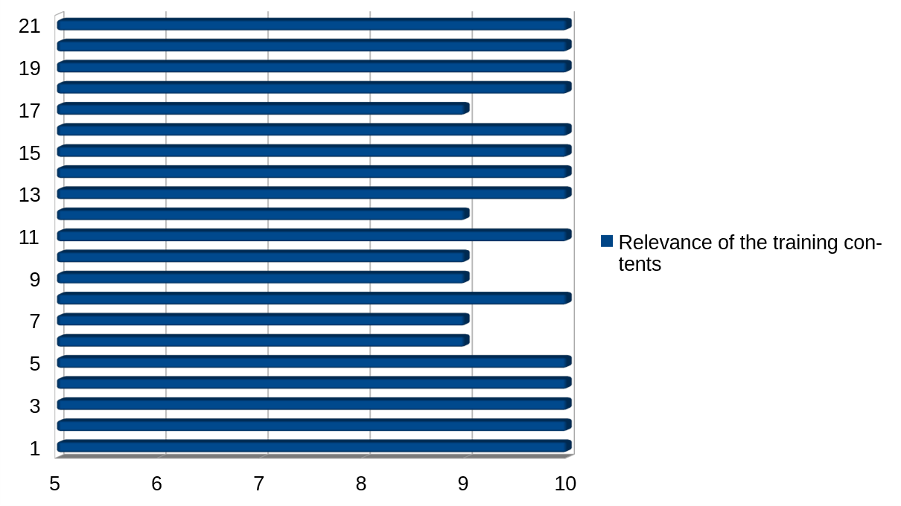
Participants evaluated the relevance of the workshop contents very positively, emphasizing the usefulness of the modules for their teaching activities and institutional needs.

Graph 2 – Quality of the Training Methodology

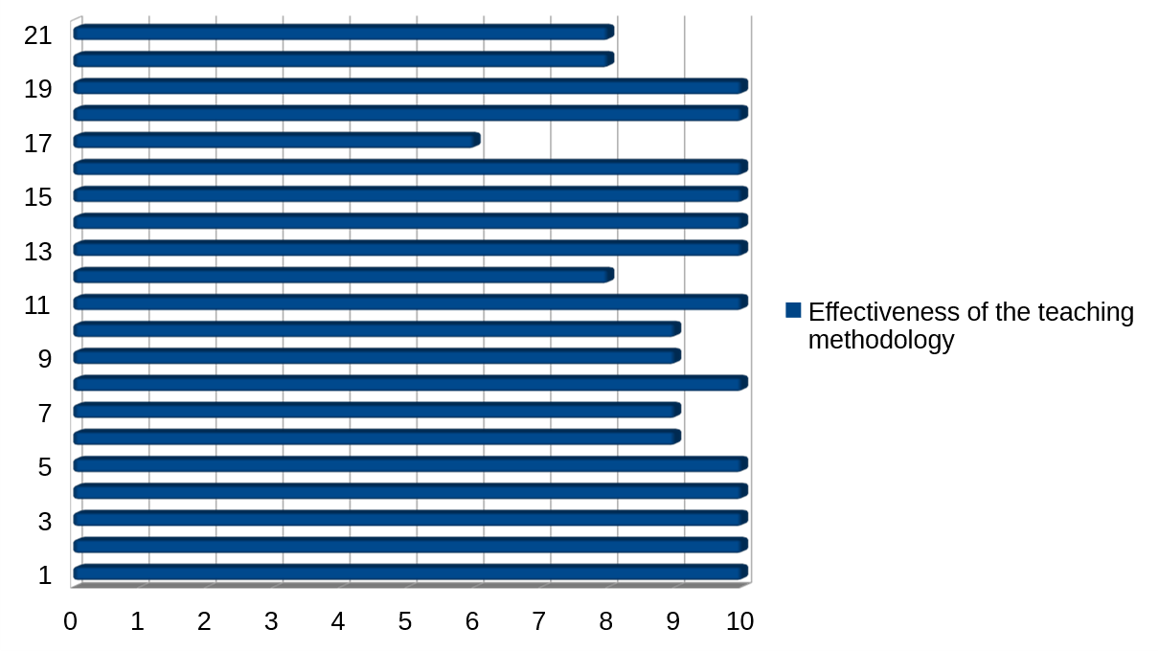
The interactive and experiential methodology received highly positive feedback. Participants particularly appreciated the balance between theoretical input and practical activities.

Graph 3 – Trainers’ Competences

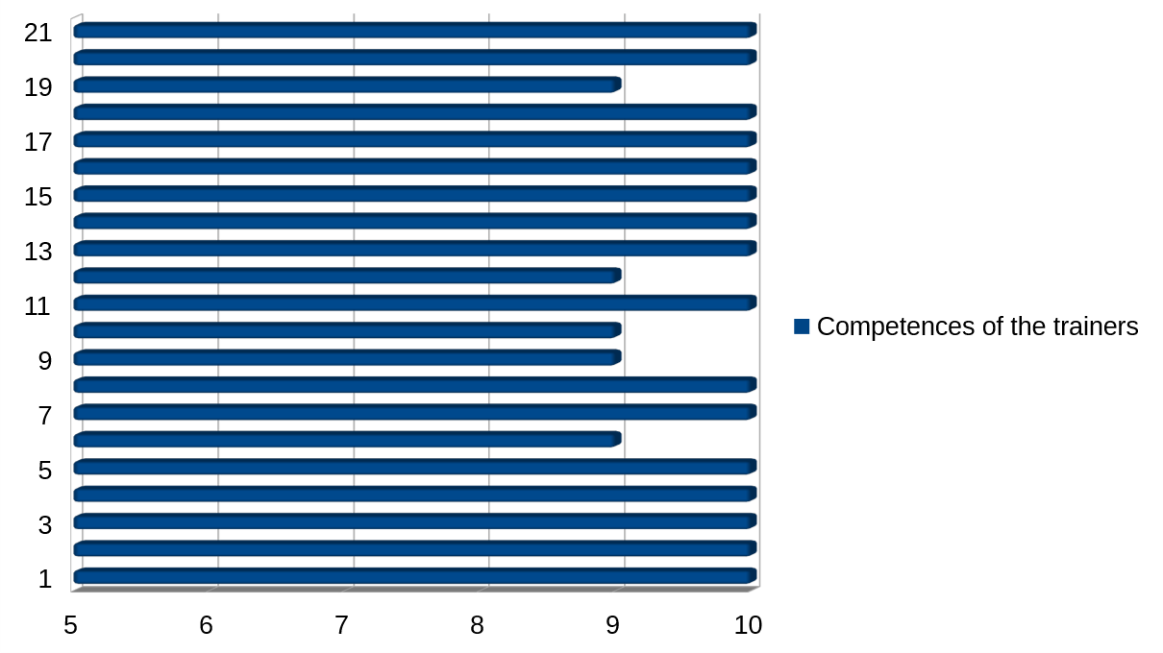
The trainers were evaluated very positively in terms of expertise, clarity and availability. Participants appreciated both the academic quality and the practical orientation of the sessions.

Graph 4 – Usefulness and Clarity of the Teaching Materials

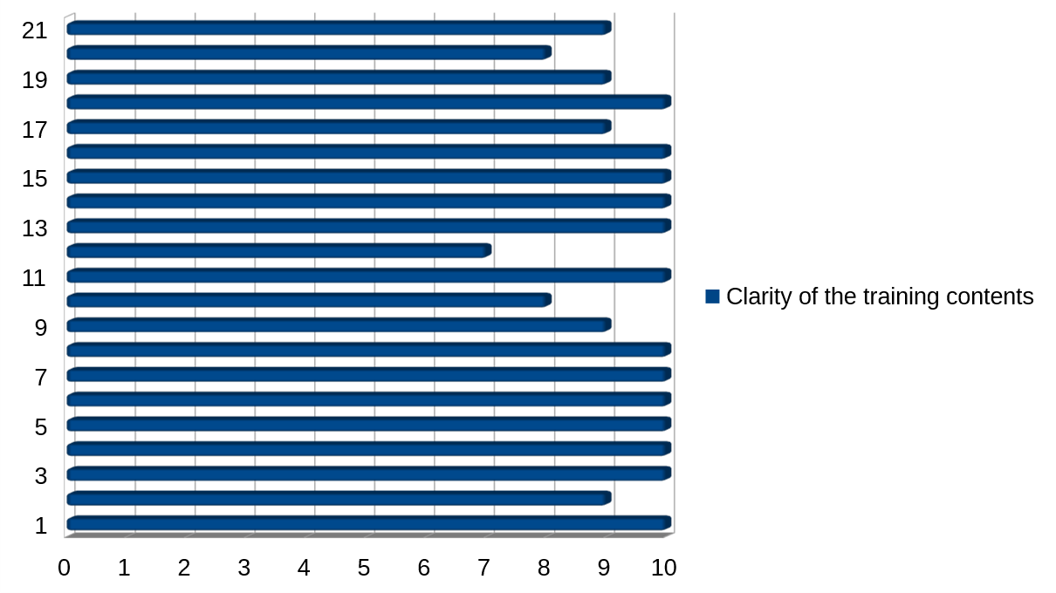

Graph 5 – Accessibility of the Teaching Materials

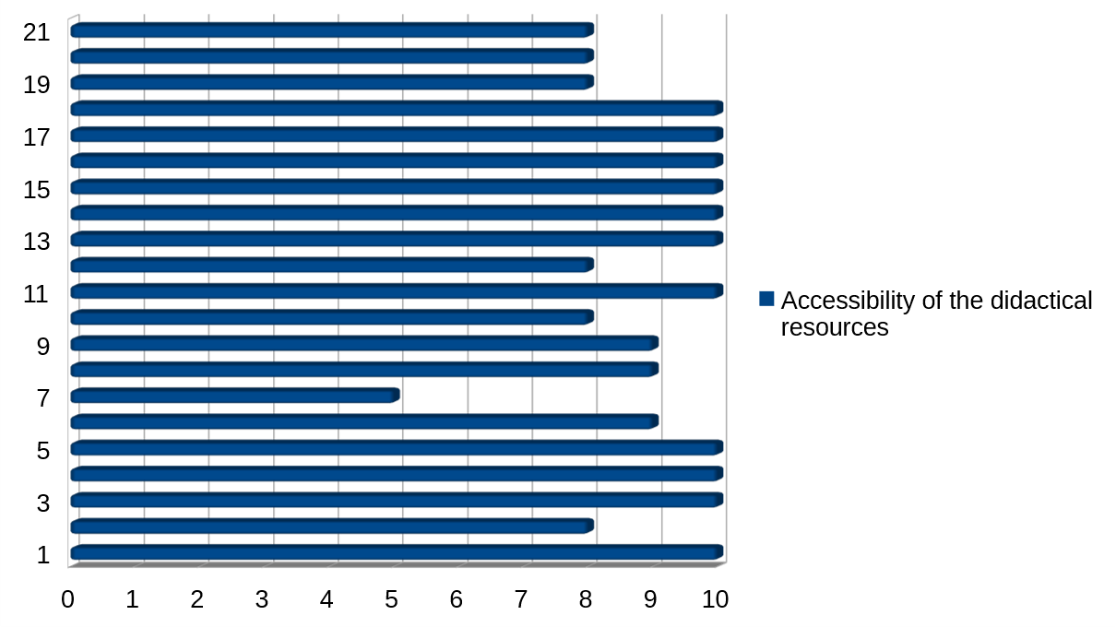

Participants considered the teaching materials accessible, well-structured and adaptable to their own educational contexts.

Graph 6 – Overall Satisfaction

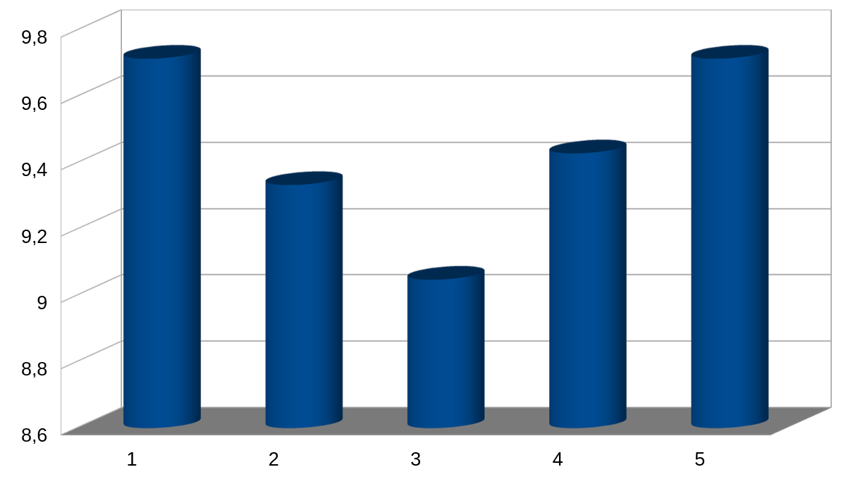
Graph 6 displays the average scores of graphs 1 to 5. The general average score was 9.45. Therefore, the overall level of satisfaction with the workshop was extremely high. Participants highlighted the value of the international exchange and the opportunity to discuss common challenges and solutions.

Qualitative comments also emphasized:

- the practical and interactive nature of the workshop;
- the usefulness of role-play and case-study activities;
- the relevance of entrepreneurship education for graduate employability;
- the applicability of the teaching tools within South African institutions;
- the importance of continuing collaboration among partner institutions.

4. Conclusion

The Transnational Workshop on Entrepreneurial Education had a significant positive impact on the target groups involved. The workshop strengthened participants’ competences in entrepreneurship education, promoted innovative and experiential teaching methodologies and fostered international collaboration among partner institutions.

The activities contributed to increasing awareness of entrepreneurial and work-integrated learning approaches and provided participants with practical tools that can be adapted, refined and disseminated within their own institutions.

The workshop also represented an important step in the implementation of WP2 objectives, particularly with regard to the development and transfer of innovative teaching tools and the strengthening of institutional capacities in entrepreneurship education.

Overall, the workshop successfully fulfilled its objectives and laid the foundations for the subsequent dissemination activities to be carried out by the South African partner institutions through national workshops involving lecturers and students.

Attachments
Please include in the report:
- Photos of the event
- Training material (presentations, hand-outs, etc)

